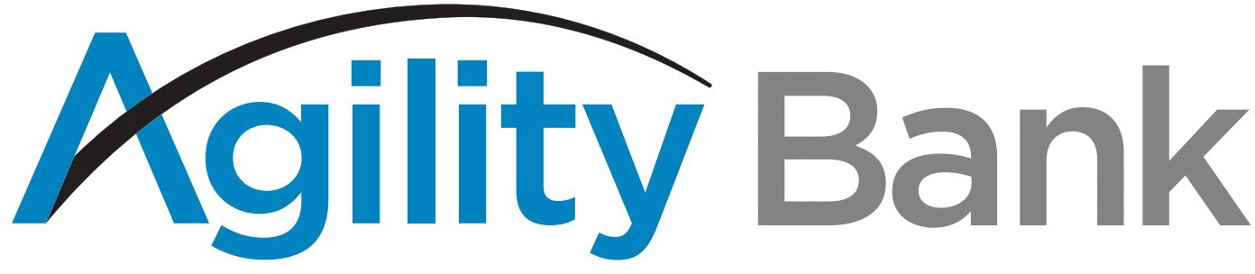

Incoming Domestic Wire Instructions

Bank ABA/Routing Number: 113026243 Receiving Bank: Agility Bank N.A.
Receiving Bank Address: 2401 N. Shepherd Dr Ste 140
Houston, TX 77008

Incoming International (US/Foreign Currency) Wire Instructions

Receiving Bank: TIB Dallas
Receiving Bank Address: 11701 Luna Road
Farmers Branch, TX 75234
SWIFT CODE: TIBBUS44
Beneficiary: Agility Bank N.A.
2401 N. Shepherd Dr. Ste 140
Houston, TX 77008 Beneficiary Account Number: 1032143
For Further Credit: (Client name and account number)

Agility Bank N.A. 713-324-8810 www.agility.bank 10.22

